LIGHTHOUSE

Lighthouse is an open-source, automated tool for improving the quality of web pages. You can run it against any web page, public or requiring authentication.

It has audits for performance, accessibility, progressive web apps, SEO and more.

To install the extension:

1. Download [Google Chrome for Desktop](https://www.google.com/chrome/browser/desktop/).
2. Install the [Lighthouse Chrome Extension](https://chrome.google.com/webstore/detail/lighthouse/blipmdconlkpinefehnmjammfjpmpbjk) from the Chrome Webstore.

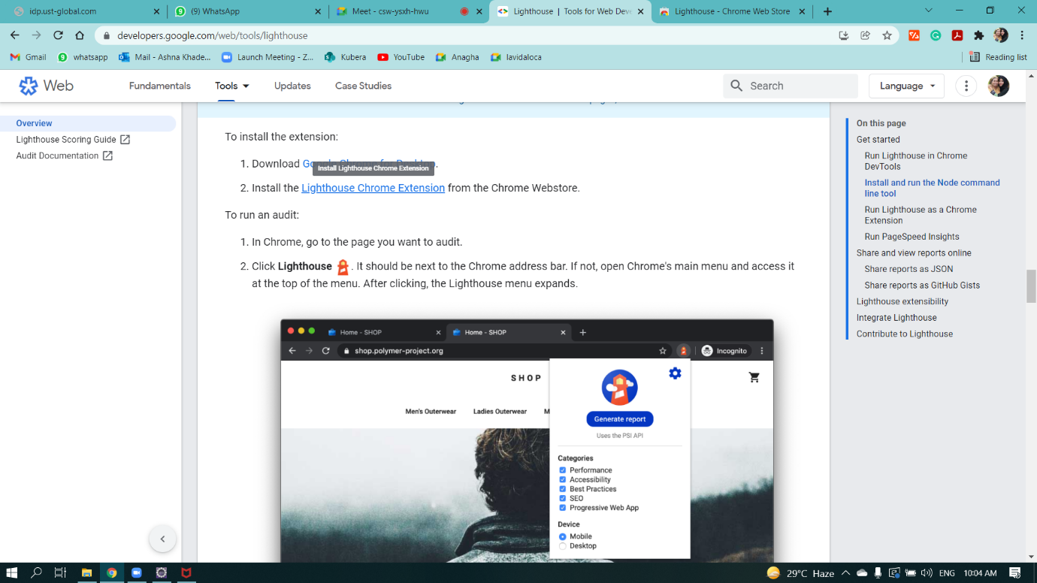

* Adding Lighthouse extension to chrome

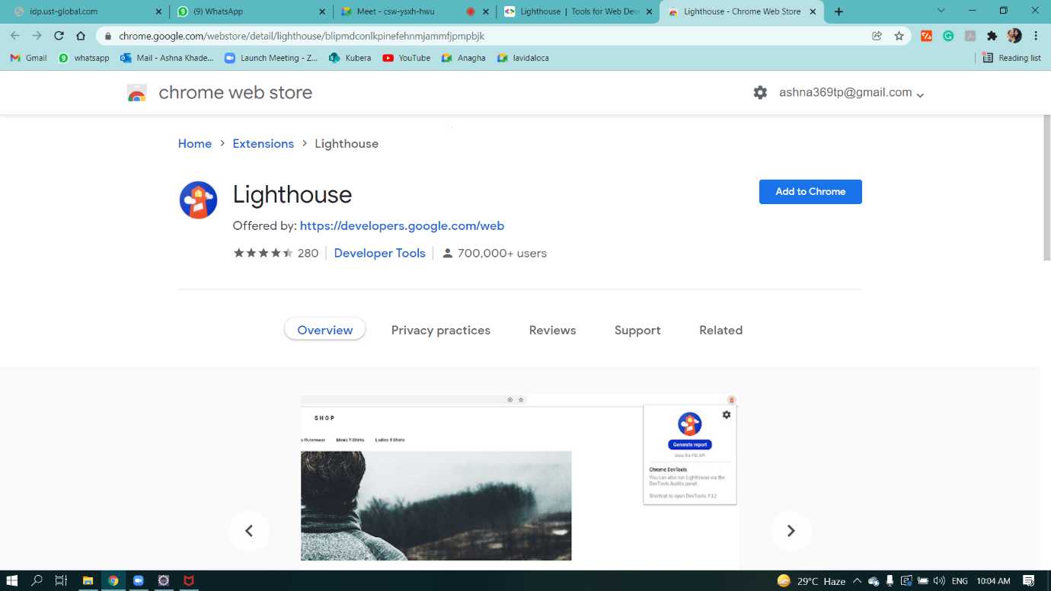

Quality assessment of Urban Ladder Website:

To run an audit:

1. In Chrome, go to the page you want to audit.
2. Click **Lighthouse** Lighthousefrom inspect section of the corresponding website.

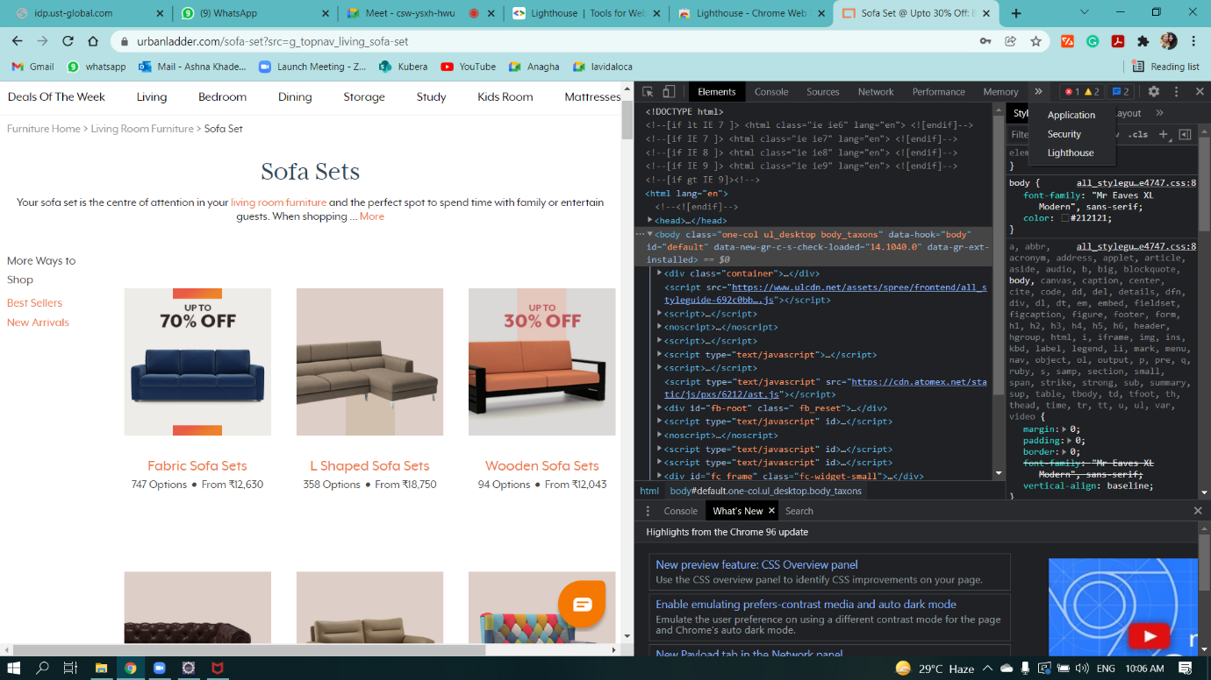

* Select the categories for which we have to generate report.
* Then click on Generate report.

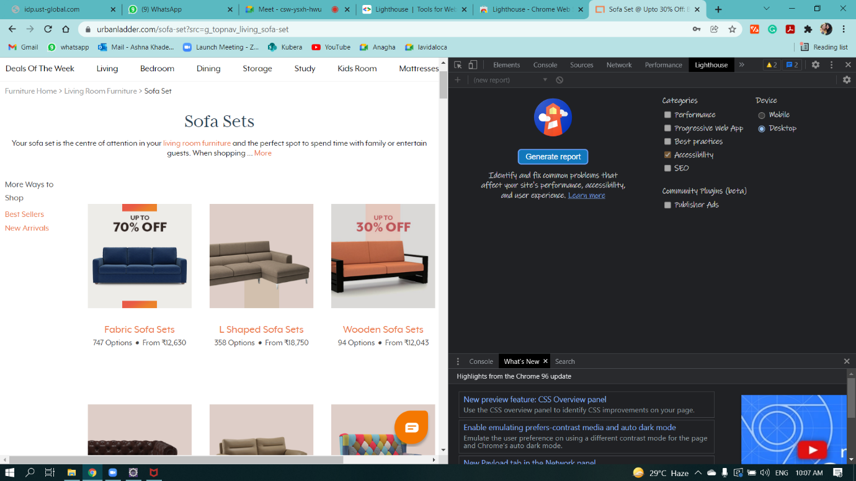

* Below shows the Accessibility corresponding to the report generated.

